
Mobiquest Solutions Pte Ltd
6 Ubi Road 1, Wintech Centre #05-13, Singapore - 408726
Tel: 65-67493202, Fax: 65-67493212
Email: info@mobiquest.net
URL: www.mobiquest.net

Document | MobileFirst – Project Deployment
Release Version | 1.0
Release Date
Approval Date

VERSION HISTORY

Version # | Release Date | Description | Updated By
1.0 | 21st Dec 2016 | Worklight – Project Deployment | Reej

TABLE OF CONTENTS
1 Purpose 3
2 Deployment 3
3 Deployment Procedure 3
4 Deploying war File 3
4.1 Creating a MobileFirst Server Configuration 4
4.2 Editing Existing configuration and Redeploying 5
4.3 Adding worklight Runtime Environment To The Configuration 5
4.4 Replacing the war file of a Deployed Runtime 5
4.5 Stopping and Restarting Server 6
5 Deploying Adapter and Application Files 6
5.1 Deploying the Adapter 6
5.2 Deploying the Application 8
6 Reference 9

Purpose
This document describes how to deploy the project to the external worklight server

Deployment
After we have developed an application in Eclipse and the embedded server, we need to deploy it to a separate test and production environment. After building a project which contains one or more applications in worklight studio the below set of files will be generated in the bin folder of the worklight project
- war file
- Set of .wlapp files
- .adapter file
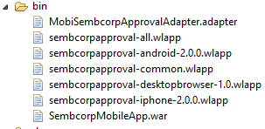

- A single war file is created for every project irrespective of the number of apps it contains.
- When we build the entire app, a file named appname-all.wlapp is created containing the code and resources of all environments that are supported by the app.
  - Example: sembcorpapproval-all.wlapp.
- If we build an app for specific environment, then a file named appname-env-version.wlapp is created per environment.
  - Example:
    - sembcorpapproval-android-2.0.0.wlapp – if built for android
    - sembcorpapproval-iphone-2.0.0.wlapp – if built for iPhone and so on for the specific environments.

Deployment Procedure
- Look for worklight.properties file in server/conf. Make sure to change the default values for the worklight configuration relevant to the test or production server.
- Please make sure the server version and the studio version are same. If there is any conflict then there would be errors while deploying a war file built from a different studio version to the server.
- The first thing to deploy is the project war file.
- After deploying the war file and restarting the server, the apps and adapter files needs to be deployed.

Deploying war File
- Copy the war file from the bin folder in eclipse project setup in the local system to the remote system where the server is installed.
- We can deploy the war file using the Server Configuration Tool
- The server configuration tool must be started on the computer on which the server is installed.
- The server configuration tool maintains the status of configuration server components, whether they are deployed or not.
- We need to create a worklight server configuration and then add a worklight runtime environment to deploy the project war file, apps and adapters.

Server Configuration Tool Main Window

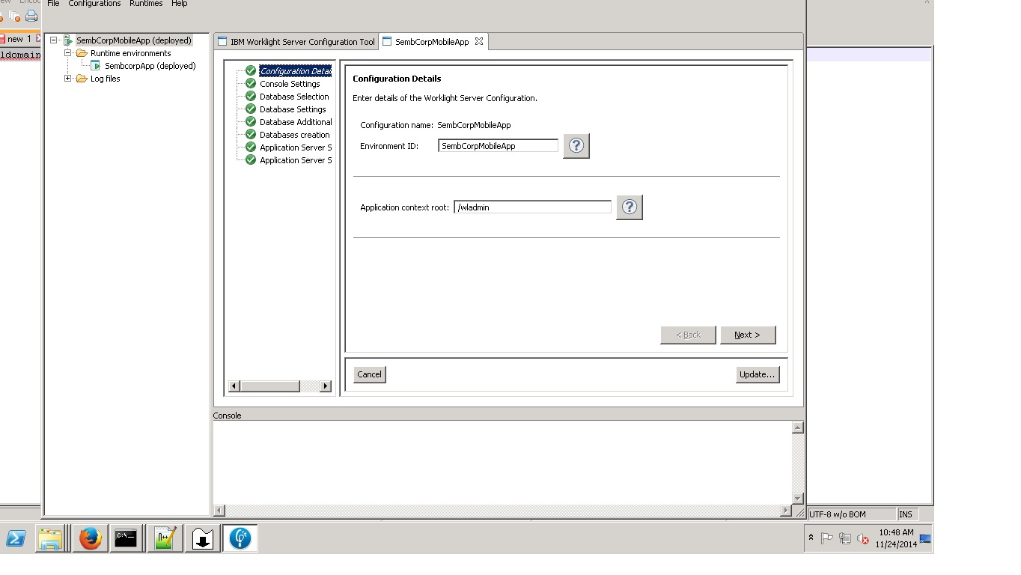

Creating a MobileFirst Server Configuration
- To open the server configuration tool, from start menu select IBM Worklight Server > Server Configuration Tool. Refer the above image for Server Configuration tool main window
- Select Create a Worklight Server configuration
- Give a name to the configuration
- In the console settings window, enter the context root of the worklight console.
- In the database properties window
  - Select the database type – IBM DB2, Oracle, MYSQL(in our case it is IBM DB2)
  - In the next window, enter the details to connect the database instance.
  - In database additional properties window, enter the parameters to connect to the administration database.
- In Application Server choice window,
  - Select the application server type - WebSphere Application Server, WebSphere Application Server Liberty profile, or Apache Tomcat. Our case it is WebSphere Application Server Liberty profile.
- When all the required data is entered, click Deploy. Once it is done, the worklight administration components are installed in the application server and connected to the database.

Editing Existing configuration and Redeploying
We can edit and modify an existing Worklight Server configuration. If you select this action, the work flow is as follows:
- We are prompted to select one of the configurations visible in the Navigation view.
- If passwords are required to redeploy the configuration, you are prompted to enter them.
- After you enter the passwords, the configuration is checked for errors.
- If errors are found, a report is displayed.
- You can then edit the configuration.
- If the configuration contains no errors, the Redeploy button is enabled.
- When we click Redeploy, the Worklight administration components are uninstalled from the application server, and reinstalled with the new parameters.

Adding worklight Runtime Environment To The Configuration
To create a new worklight runtime environment, follow the below steps:
- Select worklight Server Configuration
- Select File > Add MobileFirst runtime environment.
- Fill in a name for the environment
- Select the path for the Worklight project WAR to be deployed
- Provide the database credentials
- After providing all the necessary information, the deploy button is enabled.
- If the database operations are successful, then worklight server is deployed to the application server.

Replacing the war file of a Deployed Runtime
After the war file has been deployed, and the next time if we need to deploy a new war file with some updates, then we can select the runtime, and click Replace Project WAR file, and select the new war file from the location, and click redeploy.
We can use the server configuration tool to deploy, redeploy or undeploy an existing war.
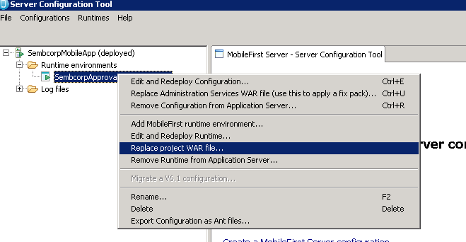

Stopping and Restarting Server
After the war file has been deployed, we need to restart the server, for the changes to take effect.
- Command to stop the server: <server installation path>server.bat stop <server name>
Example: C:\Program Files\IBM\WebSphere\Liberty>bin\server.bat stop wl_prod_server

- Command to start the server: <server installation path>server.bat start <server name>
Example: C:\Program Files\IBM\WebSphere\Liberty>bin\server.bat start wl_prod_server

Deploying Adapter and Application Files
The Adapters and application files can be deployed only after the war has been deployed and server is restarted.
- We can use the worklight console to directly deploy the app and adapter files.
- If and only if one project is deployed in the server, we will see the catalog page of the worklight console.
- If several projects are deployed, we need to select the project for which we need to deploy the adapter and app files.

Deploying the Adapter
Follow the below steps to deploy the adapter.
- Browse the MobileFirst console URL.
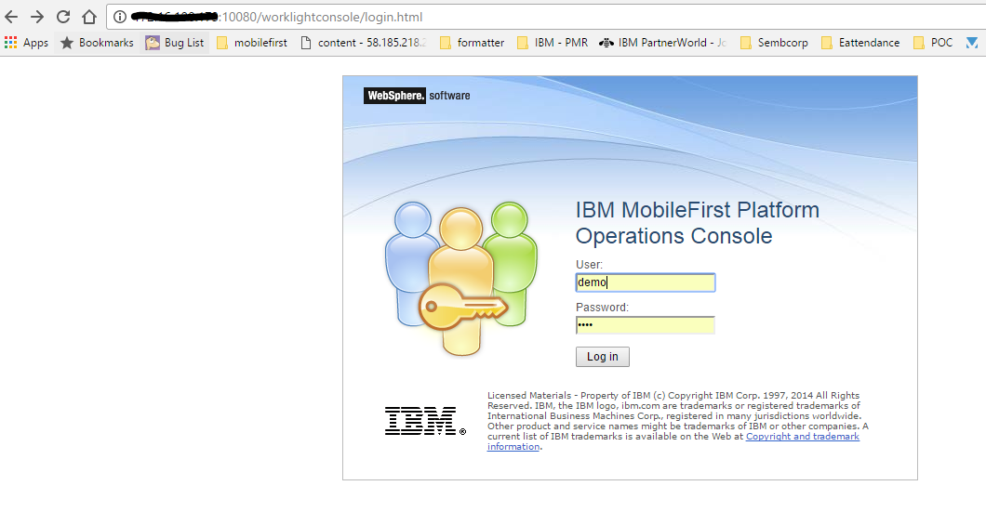
- Key in the username / password to open the operations console.
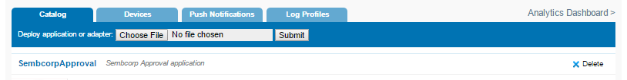
- Select Choose File, and navigate to the “.adapter file” and select it.
Note: For building the adapter – refer the document Building MobileFirst Project_v1.0.doc
- Click Submit.
- After submitting, a message is displayed indicating whether the deployment action succeeded or failed.

- If successful, the deployed adapter is added to the catalog:
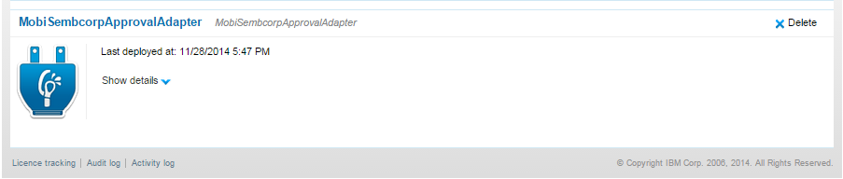

- On clicking the show details, we can see the connectivity details and list of procedures.
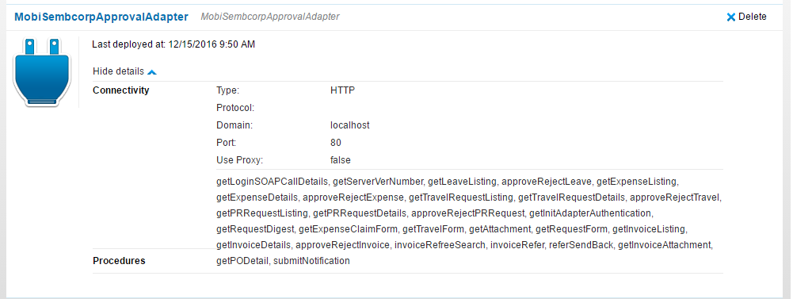

Deploying the Application
Follow the below steps to deploy an application

- Click Choose file. Then navigate to the “all.wlapp” file and select it.
- Click Submit, a message is displayed indicating whether the deployment action succeeded or failed.
- On Successful submission, the deployed application is added to the catalog.
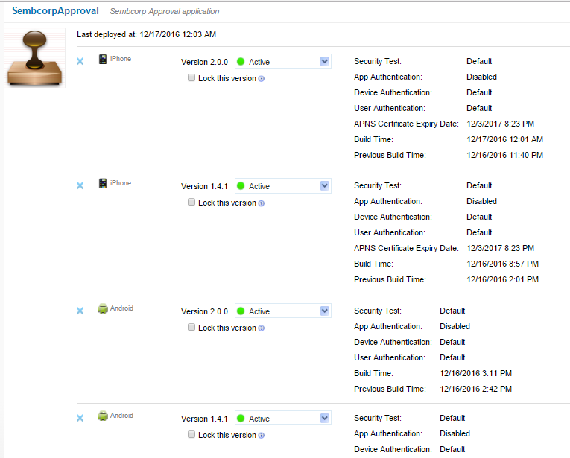

- Repeat steps 1 to 3 for each app to be deployed.

Reference
http://www.ibm.com/support/knowledgecenter/en/SSHS8R_6.3.0/com.ibm.worklight.deploy.doc/topics/c_deploy.html

